**IBM NAAN MUDHALVAN**

**WEBSITE TRAFFIC ANALYSIS**

|  |
| --- |
| **Name : JAYANTHI M**  **Reg no : 420421104030**  **College :APEC**  **Project :1** |

**TABLE OF CONTENTS**

|  |
| --- |
| * Importance of stats/analysis  * How/where do I track my marketing activities  * What you need to know to get started  * Goals and Conversions  * Identifying marketing activity in Google Analytics with Campaigns  * How to start interpreting your data/key questions to ask  * Regular reporting and drawing regular insights  * Useful resources |

**IMPORTANCE OF STATS/ANALYSIS:**

**\* Data analytics is the analysis of qualitative and quantitative data from your business and the competition to drive continual improvement of your users’ online experience to enable you to achieve your organisational goals.**

**\* It allows you to measure, manage and analyse marketing performance to maximise efectiveness.**

**INTRODUCTION :**

**\*Website traffic analysis involves the process of collecting, analyzing, and interpreting data related to the visitors and their interactions with a website.**

**\*This analysis is crucial for understanding how your website is performing, identifying areas for improvement, and making data-driven decisions to achieve your online goals.**

**\*Here are the key steps and components of website traffic analysis:**

**1. Data Collection:**

**• * Web Analytics Tools: Use web analytics tools like Google Analytics, Adobe Analytics, or Matomo (formerly Piwik) to gather data about your website & visitors, their behavior, and other relevant metrics.**

**• *Server Logs: You can also analyze server logs to gather information about user requests, IP addresses, and user agents. This data can complement analytics tools.**

**2. Key Metrics:**

**• Traffic Sources: Understand where your visitors are coming from.**

**This can include organic search, direct traffic, referral traffic from other websites, social media, and paid advertising.**

**• Visitor Demographics: Analyze the demographic information of your**

**audience, such as age, gender, location, and device type.**

**• Pageviews: Track the number of pages viewed on your website. This can help identify popular content and user engagement.**

**• Bounce Rate: Measure the percentage of visitors who leave your site after viewing only one page. A high bounce rate may indicate issues with your landing page or content.**

**• Conversion Rate: Monitor how many visitors complete desired actions on your site, such as making a purchase, signing up for a newsletter, or filling out a contact form.**

**• Average Session Duration: Determine how long visitors spend on your site on average. Longer sessions can indicate higher engagement.**

**• Exit Pages: Identify the pages where visitors commonly exit your site, which can reveal potential issues or opportunities for**

**improvement.**

**3. Traffic Segmentation:**

**•* Analyze traffic by segments such as new vs. returning visitors, device type (desktop, mobile, tablet), geographic location, and referral sources.**

**•* Segmenting your data helps you tailor your strategies to specific audience groups.**

**4. User Behavior:**

**•* Track the user journey through your website, including the path they take, the pages they visit, and the actions they perform.**

**•* Heatmaps and session recordings can provide visual insights into user behavior and interactions.**

**5. Content Analysis:**

**• *Identify the most popular and engaging content on your site. This helps you focus on creating similar content or optimizing existing pages.**

**•* Evaluate the performance of landing pages, blog posts, product pages, and other important content.**

**6. Goal Tracking:**

**• *Set up goals and conversion funnels in your analytics tool to measurethe success of specific actions or objectives.**

**• *Analyze the steps users take to complete these goals and optimizethe process.**

**7. SEO Analysis:**

**•* Monitor keyword rankings and organic search traffic.**

**• *Identify opportunities to improve search engine optimization (SEO) by targeting relevant keywords and optimizing on-page elements.**

**8. Competitor Analysis:**

**•* Compare your website&#39;s performance to that of competitors.**

**• *Identify areas where your site can outperform or learn from**

**successful competitors.**

**9. Regular Reporting:**

**•* Generate regular reports to track key metrics and trends over time.**

**•* Share insights with relevant stakeholders to inform decision-making.**

**10. Continuous Improvement:**

**• *Use the insights from your analysis to make data-driven decisions and continually optimize your website&#39;s performance and user experience.**

**\*Website traffic analysis is an ongoing process that requires attention and adjustment to keep your website aligned with your goals and user expectations.**

**Uses of the provident website analytics :**

1. **Tracking, measuring the rate of success in actions and programs Example: commercial campaigns.**

**2. Identifying the web applications problems and improving performance.**

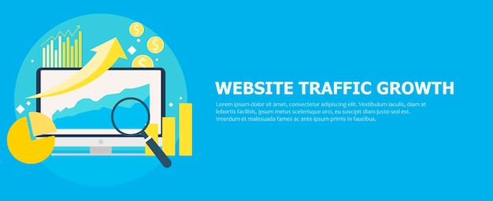

**The widely used metrics in web analytics are:**

**• Visitor count**

**• Visited duration**

**• Exit rate.**

**PURPOSE TO DEVELOP THE-PROJECT:**

**● To track the different pages viewed.**

**● To Track Average visit duration for each page. View of the user's visited-view. And gothrough the visitors or visiting the popular site for-tough and usage-view the website.**

**● We can track Average page duration. The healthy pages visited the good-view for the department.**

**● To know or acquire the know to deliver web sites.**

**● To Track of providential dito de promotional campaigns and perform-maintenance.**

**● To track most requested pages by-users.**

**● To track the path sequences used by the visitors while accessing our websites.**

**Controlling web traffic:**

Persons for visiting the site most importantly for the few farts of the webpage will be helpful for us to maintain the secured website. Allowing the access for website based on the based on the geographical network with the help of the google maps will help the authorized person to find the exact traffic of the website.

**Increase website traffic:**

Website-traffic is often increasing by space of a website in search engines and buying advertisements, which involves-email in bulk, pop-up advertisements, and also the page-annunciations. Website-traffic also can be built as per purchasing the advertisements which will be provided offline basedadvertising. If the website page will provide details with a page that appears-on any surf, then it cannot be found by someone visiting its related pages in a great way.

**Flux Traffic:**

Website traffic which arrived-from a list which is not paid at gateways or indexes is typically mentioned as a Flux traffic. Flux traffic is often produced by containing the web site index , search engines, guides. To track the number of visitors of each page in the-website.

Your analyzed data will also tell about how well your search engine optimization on your site is working. Not only these two things, how content and attract visitors.

**Existing system:**

The Existing System of web-traffic-analyzers don't have any tool to trace any information about the website like how many people have visited that website or from where it's open.

**Overloaded traffic:**

When there is a huge amount of website traffic it can slow down access. but when the website-traffic is reduced it can become or can make provident for your website. This is because the increase of requests for files on the website happens The main aim of the project is business methodology-modernization. We also have been giving gibberish trying to computerize different-forms of various web traffic. Scope of any software depends upon the following things.

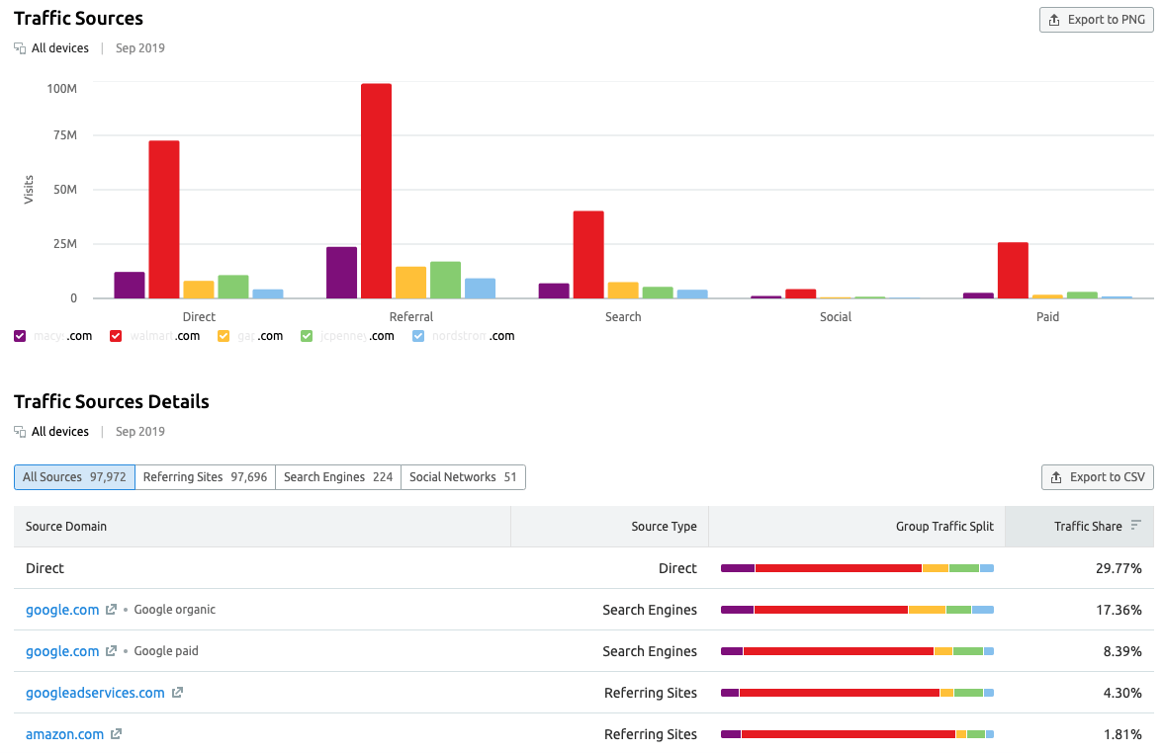

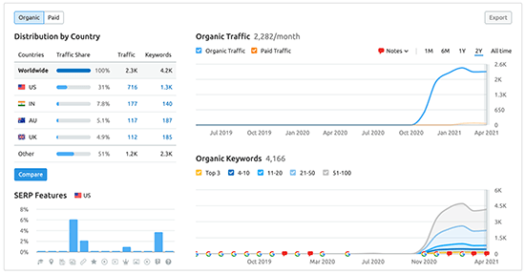

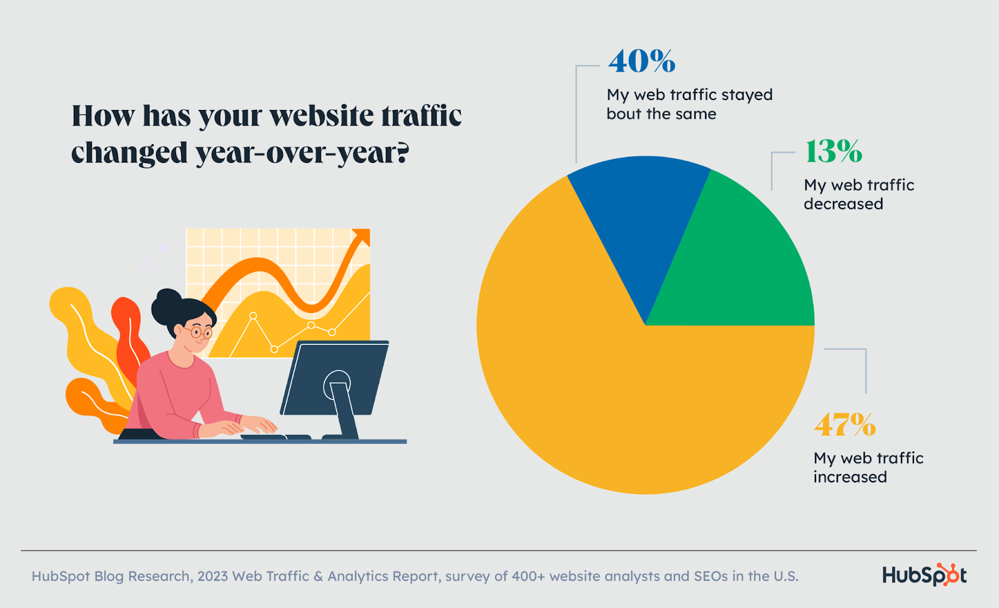

**Practical implementation**

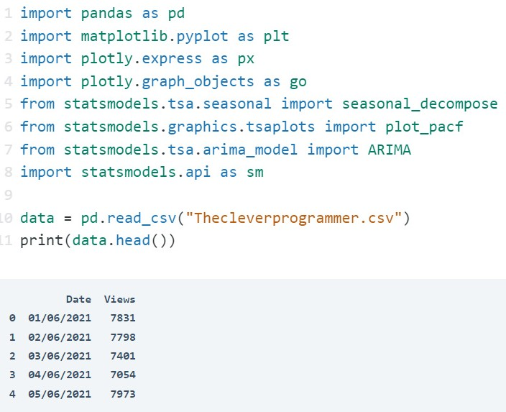

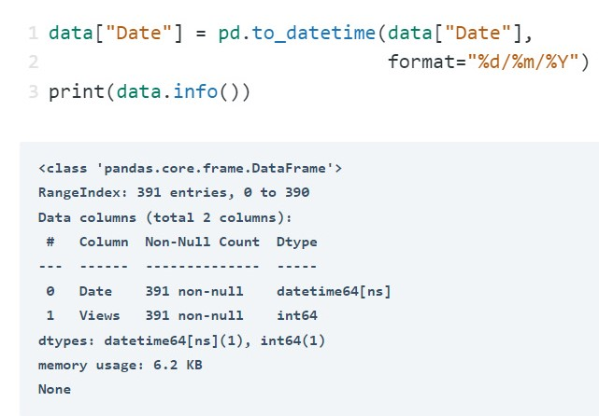

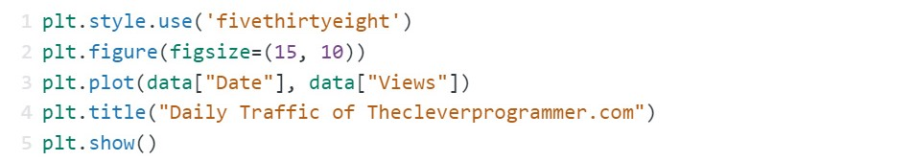

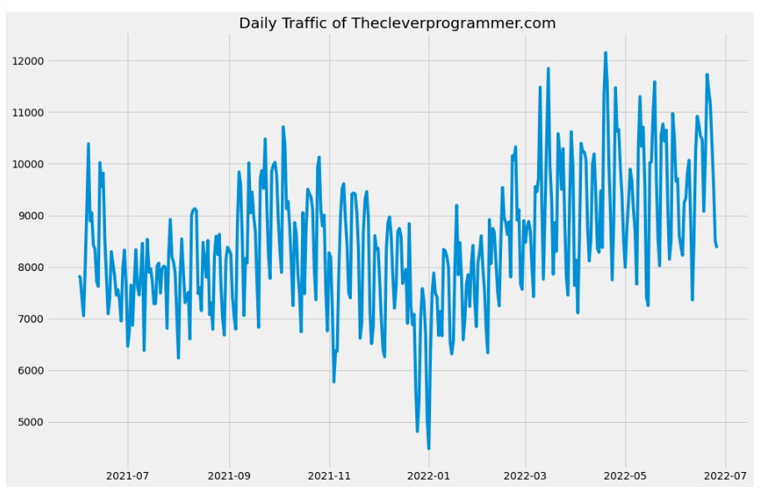

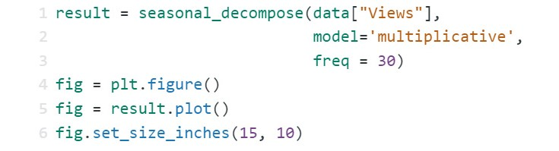

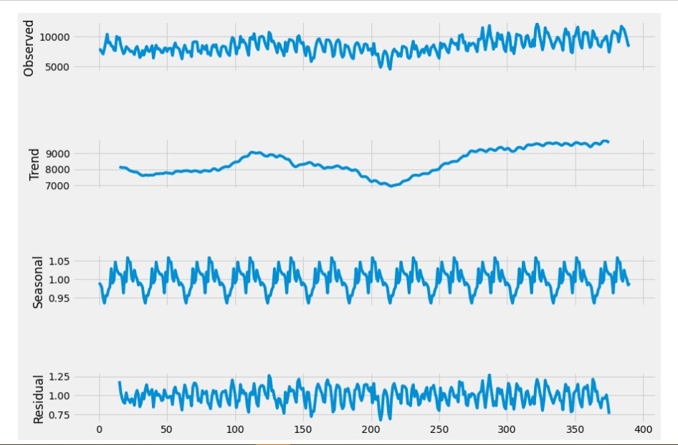

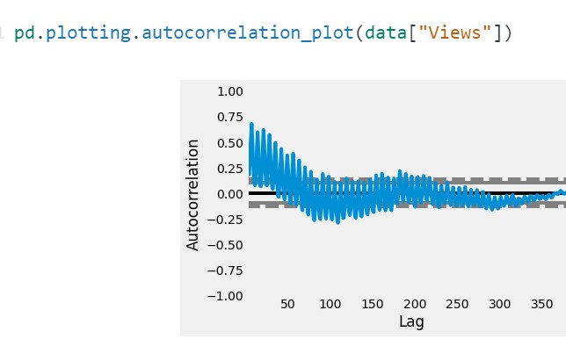

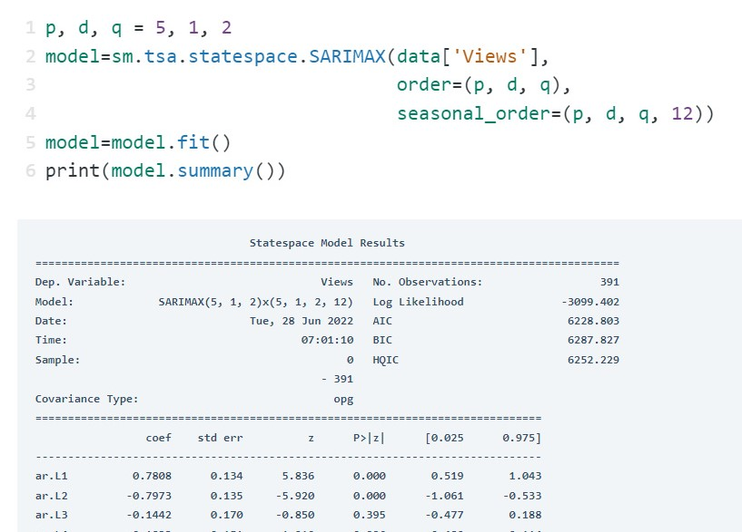

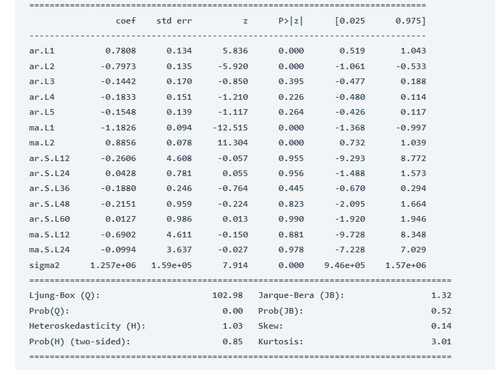

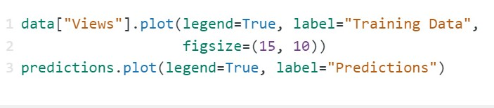

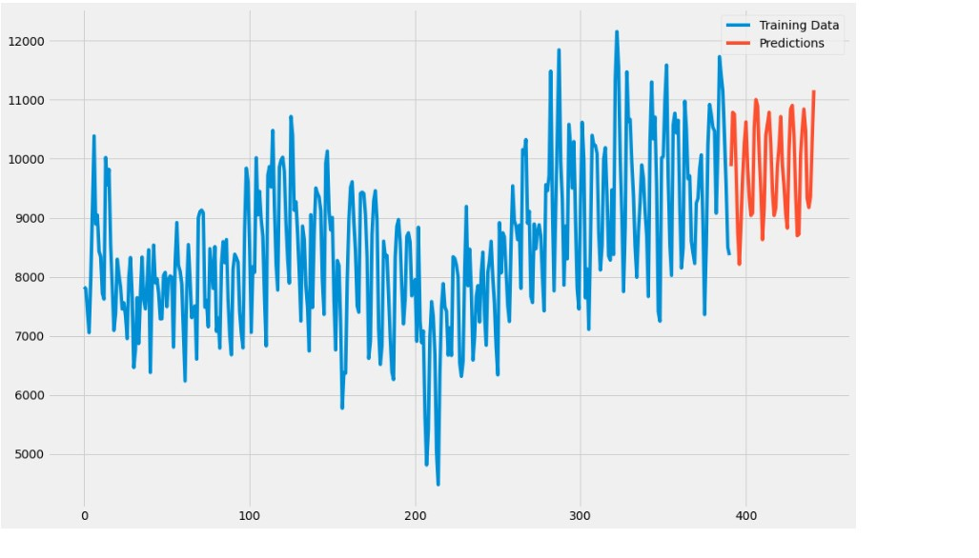

**SUMMARY**

*Web traffic analytics refers to collecting data about who comes to your website and what they do when they get there. That data is crucial to building effective sales and marketing strategies. While most people assume more traffic is always better, that's not always true

*Web analytics is the collection, reporting, and analysis of website data. The focus is on identifying measures based on your organizational and user goals and using the website data to determine the success or failure of those goals and to drive strategy and improve the user's experience.